DATN-2377- Advanced Analytical Tools and Methods
Lab Work 2 for Chapter 11
(Total 100 points)

Perform the following exercises in your Jupyter notebook.

Submission Guidelines:
- Ensure that you complete this lab work using a Jupyter Notebook.
- Once the lab work is finished, convert the file into HTML format.
- Lastly, upload the HTML file to D2L for submission.

Chapter 11:
Exercise 11-1 Create a multiple regression (35 points)
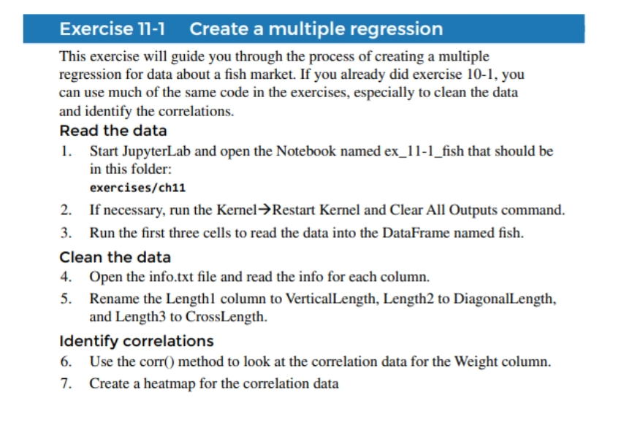
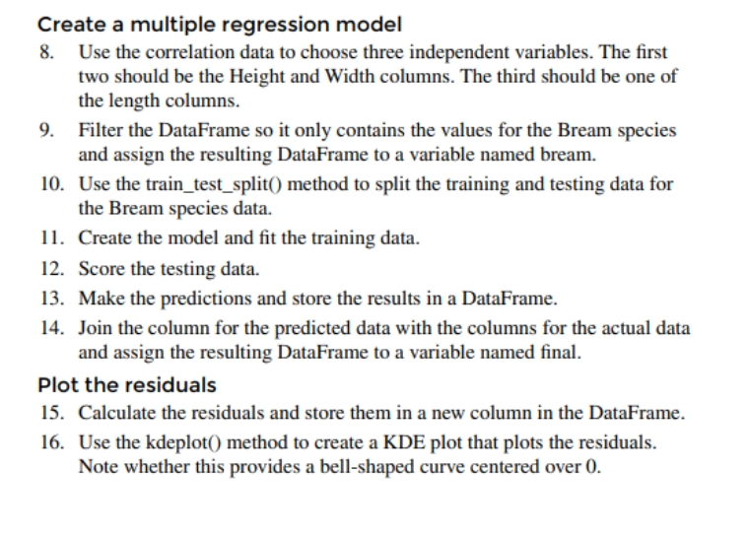
The Medical Costs case study (65 points)

